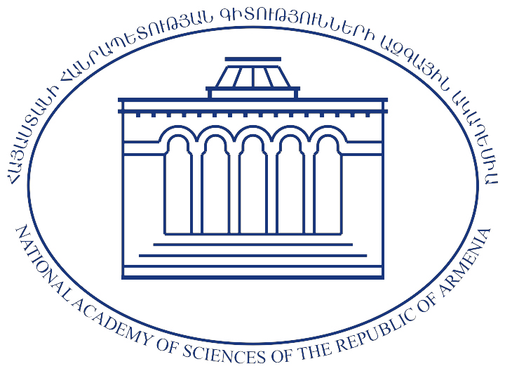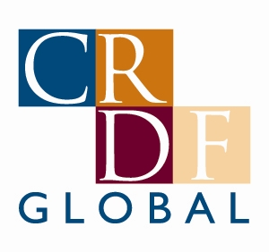
The List of grantees awarded in the framework of "Graduate Research Support Program-2010"

The List of grantees awarded in the framework of "Graduate Research Support Program-2010" competitions of The National Academy of Science (NAS RA), The National Foundation of Science and Advanced Technologies (NFSAT) and the U.S. Civilian Research & Development Foundation (CRDF Global)
Graduate Research Support Program
ECSP-10-01 | Andranik Chavushyan | Institute of molecular biology NAS RA
ECSP-10-02 | Anna Mkrtchyan | Institute of biotechnology NAS RA
ECSP-10-05 | Sergej Abrahamyan | Institute of informatics and automations problems NAS RA
ECSP-10-07 | Andranik Durgaryan | Institute of biochemistry NAS RA
ECSP-10-10 | Rafael Mirzoyan | Institute of physical research NAS RA
ECSP-10-17 | Tigran Pogosyan | Institute of radiophysics and electronics NAS RA
ECSP-10-18 | Melania Grigoryan | Institute of radiophysics and electronics NAS RA

